Final Project Documentation for

Web Publishing System

**Prepared by:** Abdelrahman Shemies **Date:** 8/1/23

1. Project description

## Statement of work

## Web Publishing System project for a local editor of a regional historical society. The project will include the development of a software system to assist in the automation of the article review and publishing process, as well as the integration of this system into the editor's existing workflows and processes.

## Scope of Work:

The scope of work for this project includes the development and implementation of an online journal website and related systems for managing and publishing articles. This will involve the creation of user interfaces for authors, reviewers, and editors, as well as the development of a database to store articles, authors, reviewers, and other relevant information. The hardware components of the project will include servers for hosting the website and database, and possibly client machines for the editors. The software components will include the web server software, database management software, and any custom software developed specifically for this project. The exact nature of the work will involve designing and implementing the user interfaces, setting up and configuring the hardware and software components, and testing and debugging the system.

The Web Publishing System will have the following features:

* An interface for the editor to create and manage a list of authors and reviewers, including the ability to add, edit, and delete entries.
* An interface for authors to submit articles for review, including the ability to attach files and enter metadata such as the article title and abstract.
* An interface for reviewers to view and review articles, including the ability to leave comments and feedback for the authors.
* An interface for the editor to view and manage the review process, including the ability to assign articles to reviewers, view comments and feedback, and make decisions on whether to accept or reject articles.
* An email system to facilitate communication between the editor, authors, and reviewers, including the ability to send and receive preformatted reply forms.
* A relational database to store information about authors, reviewers, and articles, including metadata such as the article title and abstract, and the status of the review process.

**II.** Project proposal and backup data (request for proposal, statement of work, proposal correspondence, and so on

## Location of Work:

The work for this project will primarily take place at the Headquarters of the company, where the managing, developing, and implementing will occur. Internal testing will be done on the company's servers where the online journal is hosted to assess security, performance, and unauthorized actions. Additionally, there will be beta testing for external users to evaluate the acceptance criteria and ensure a user-friendly interface for new users.

## Period of Performance:

The work is expected to start on 1st of February 2023 and end on 30th November 2023. The working hours are from 9 am to 5 pm from Sunday to Monday. A maximum of 70 hours can be billed per week.

## Deliverables Schedule:

1. Initial design document: This document should outline the overall architecture and functionality of the system, including user roles, use cases, and technical requirements.
2. Prototype: A functional prototype of the system. This should include basic functionality such as user authentication, article submission, and review process.
3. Final product: The complete and fully functional web publishing system should be delivered by the end of the project period. This should include all features and functionality specified in the initial design document, as well as any additional features that have been agreed upon during the course of the project.
4. User manual: A comprehensive user manual should be delivered along with the final product. This manual should include instructions on how to use all features of the system, as well as troubleshooting information and support contact details.
5. Training materials: If necessary, training materials such as video tutorials or slide decks should be provided to help users get up to speed with the system. These should be delivered along with the final product.
6. Project updates and progress reports: Regular updates and progress reports should be provided to keep stakeholders informed on the status and progress of the project.
7. Testing and QA: Adequate testing and quality assurance should be carried out to ensure the system is reliable and performs as expected.
8. Maintenance and support: A plan for ongoing maintenance and support should be established and communicated to ensure the smooth operation of the system after the project is completed.
9. Security and data protection: Measures should be put in place to ensure the security and protection of user data and the system as a whole.
10. Documentation: Detailed technical documentation should be provided for the system, including design and architecture, codebase, and any other relevant information.

|  |  |
| --- | --- |
| Months |  |
| 1: February | * Initial design document * The main user interface (GUI) will be developed and delivered to the client for acceptance * User authentication functionality will be implemented to identify and verify the various actors (e.g. editors, authors, reviewers) in the system. |
| 2: March | * Prototype with basic functionality Months |
| 3-5: April-June | Meeting #1 confirming the Prototype   * The search engine will be fully developed and deployed in the system. * The backend functionality will be implemented, including any necessary data storage and processing. * The main databases for the system will be developed and implemented. * The user interface (GUI) may be modified as needed. * An external historical database will be implemented and integrated into the system. |
| 6-7:  July-August | Meeting #2   * The main and historical databases will be connected and used in the article management system. * Initial use cases for different actors (e.g. editors, authors, reviewers) will be implemented. * The editor, reviewer, and author functionalities will be added to the system. * Various use cases for these functionalities will be implemented. * Unit testing will be conducted to verify the functionality of individual components. * All test cases and scenarios will be completed. |
| 8-9: September- October | Meeting #3   * Internal and external testing will be carried out to ensure the system is reliable and performs as expected. * Testing scenarios and documentation will be provided, including any bugs discovered and how they were addressed. |
| 10: November | Meeting #4   * Integration testing will be completed to ensure all components of the system are working together as intended. * A comprehensive report will be compiled, including all testing scenarios and any bugs that were discovered and resolved. * User manual * Training materials * Project updates and progress reports * Maintenance and support plan * Security and data protection measures |

## Applicable Standards:

## Accessibility standards, such as the Web Content Accessibility Guidelines (WCAG), to ensure that the system is usable by people with disabilities.

## Security standards, such as the Payment Card Industry Data Security Standard (PCI DSS), to ensure that the system is secure and protects sensitive information.

## Data storage and management standards, such as the ISO/IEC 27001:2013 standard for information security management, to ensure that the system is designed and operated in a secure and compliant manner.

## Web development standards, such as the Hypertext Transfer Protocol (HTTP) and the HTML5 standard for web content, to ensure that the system is compatible with the latest web technologies and standards.

## Acceptance Criteria:

1. The system must be able to perform all of the specified functions, including allowing authors to submit articles, allowing reviewers to review articles, allowing editors to publish articles, and allowing readers to search and access articles.
2. The system must be able to interface with the Historical Society database to verify membership status for reviewers.
3. The system must be able to send and receive emails as described in the use cases.
4. The system must be able to update and maintain accurate and complete information in its database.
5. The system must be secure, with appropriate measures in place to prevent unauthorized access or modification of data.
6. The system must be easy to use and navigate for all user groups.
7. The system must be able to handle a reasonable volume of traffic and usage without experiencing performance issues.
8. Any necessary data backups and recovery procedures must be in place and functioning correctly.
9. The system must be tested and demonstrated to be in full compliance with any applicable industry or company standards.
10. The system must be able to handle a minimum number of concurrent users without experiencing performance issues.
11. The system must be able to store and retrieve data from the database without errors.
12. The system must be able to perform all required functions, as specified in the requirements specification document.
13. The system must be user-friendly and easy to navigate for both authors and reviewers.
14. The system must be able to send and receive email notifications and attachments.
15. The system must be able to verify the membership status of a reviewer through the Historical Society (HS) database.
16. The system must be able to search for articles by author, category, or keyword.
17. The system must be secure, with appropriate measures in place to prevent unauthorized write/delete access.
18. The system must meet any relevant industry or company standards or regulations.
19. The system must be tested and debugged prior to deployment.
20. The system must be documented with clear instructions for use and maintenance.

## Special Requirements:

* Implementing secure login and authentication measures, such as multi-factor authentication or password policies, to protect against unauthorized access.
* Ensuring that data is encrypted when it is transmitted or stored to prevent unauthorized access.
* Implementing a scalable database architecture to handle a large volume of data and ensure good performance.
* Designing a user-friendly interface with clear instructions and a logical layout of features and functions.
* Testing the system on a variety of devices and browsers to ensure compatibility.
* Allowing for customization options, such as personalization of the user interface or configurable settings for different user roles.
* Integrating the web publishing system with other tools or systems that may be used in conjunction with it, such as a content management system or a customer relationship management system.
* Ensuring compliance with any relevant regulations or industry standards, such as GDPR or HIPAA, that apply to the system. This might include implementing appropriate data protection measures and providing appropriate disclosures and consent forms to users.

|  |  |
| --- | --- |
| **Name** | **Sign-off on Team Contract** |
| **AbdelRahman Shemies** |  |
| **Ahmed Salman** |  |
| **Adham Sharaf** |  |
| **Ezz ElMayal** |
| **Moustafa ElAhmar** |  |
| **Nada Elkobtan** |  |

**Code of Conduct:** As a project team, we will:

* Uphold the security and privacy of any sensitive data.
* Maintain confidentiality in our work.
* Act with integrity and professionalism at all times.
* Respect the intellectual property of others.
* Follow company policies and procedures.
* Avoid any potential conflicts of interest.
* Abide by all relevant laws, rules, and regulations in our work.
* Foster a positive and respectful work environment.
* Avoid discrimination and promote open communication within the team.

**Participation:** We will:

* Discuss and present the work being done by each team member or group.
* Encourage all team members to contribute their opinions in group meetings and make decisions by consensus.
* Ensure that all team members are knowledgeable about the project and have mastered specific areas of expertise, so that the project can continue smoothly in case of absences.
* Each will discuss which part he’s working on or if group of team members are working on the same thing will present it.
* Each member from the team must declare his/her opinion in the group meetings session and any decision should be taken by the approval of the whole team not by the majority, as the team will all be affected by anything happen in any urgent case.
* Each must be on the same level of knowledge in the project and master a single part that he’s brilliant in it, as if one member is absent, there will always be a compensate for him, so that the project will not be terminated or stopped waiting for a specific member.
* Contribute to team discussions and decisions in a constructive manner.
* Communicate any concerns or issues to the team in a timely manner.
* Be open to feedback and willing to learn from others.

**Communication:** We will:

* Hold daily meetings to track progress.
* Meet every 2-3 months to present a workable product with full documentation.
* Communicate regularly with the project manager via email and meetings.
* Use clear and effective communication when discussing tasks and responsibilities.
* Keep each other informed of progress and any changes to schedules or tasks.

**Problem Solving:** We will:

* Analyze problems thoroughly, considering any potential drawbacks.
* Evaluate the impact of problems on the rest of the code and the project as a whole.
* Seek guidance from the project manager or senior project manager when needed.
* Consult with clients if additional information is needed to address issues.

**Meeting Guidelines:** We will:

* Start meetings by presenting individual or group work.
* Share updates on completed tasks and next steps.
* Discuss and resolve any problems that arise in meetings.
* Address any changes to project requirements and determine the best course of action.

1. Original and revised contract information and client acceptance documents

The Web Publishing System is designed to assist the local editor of a regional historical society in automating the review and publishing process for articles. It consists of two main parts: the Online Journal, which is accessible to authors, readers, and reviewers via the internet, and the Article Manager, which is used by the editor to manage the review process. The system aims to increase the editor's productivity and efficiency while being user-friendly and easy to understand.

There are four main actors in the system: authors, readers, reviewers, and the editor. Communication between the system and reviewers or authors occurs through email, while the editor has direct access to the entire system. The server hosting the Online Journal has security measures in place to prevent unauthorized write or delete access, but read access is unrestricted.

* Improving the speed and efficiency of the review and publishing process, reducing the time it takes for articles to be published.
* Increasing the reach and visibility of the articles, potentially attracting more readers and authors to the journal.
* Enhancing the reputation of the journal by providing a professional and reliable platform for publishing articles.
* Reducing the workload and administrative burden on the editor, allowing them to focus on other tasks.
* Providing a user-friendly and intuitive interface for authors, reviewers, and readers to interact with the system.
* Ensuring compliance with any relevant regulations or industry standards.
* Improving the quality of the articles published by the regional historical society by providing tools for thorough review and feedback.
* Reducing the time and effort required to communicate with authors and reviewers by using the email and preformatted reply forms provided by the system.
* Providing a valuable resource for authors and reviewers by giving them a platform to submit and review articles.

# Current Situation and Problem/Opportunity Statement

* The current situation is that the team members may not be fully trained and capable of working on all aspects of the project, which can lead to extra efforts and extra working hours. This may also result in additional training expenses and financial strain on the budget provided by the project sponsor.
* The impact of this situation is that team members may need to put in extra effort to become fully trained and proficient in all aspects of the project, which can lead to additional working hours and financial costs. This may also create tension within the team and a less favorable work environment.
* The desired state is to have all team members fully trained and capable of working on all aspects of the project, which will increase flexibility and reduce tension within the team. To achieve this, the team should discuss the additional expenses with the project sponsor and provide a report on the costs involved. This will allow the team to become fully trained and experienced, which will ultimately save costs in the long run if a team member is absent or sick.

# Critical Assumption and Constraints

Security constraints:

* Ensuring that user login credentials are encrypted and secure, to prevent unauthorized access to the system.
* Implementing measures to prevent data leaks or unauthorized access to sensitive data, such as article drafts or personal information of authors, reviewers, or readers.
* Protecting against malware or other security threats that could compromise the system or user data.
* Ensuring that the system is compliant with any relevant regulations or industry standards that apply to the handling of user data.

Potential constraints:

* Limited budget or resources for the project.
* Tight deadlines for the development and deployment of the system.
* Legal or regulatory requirements that must be met, such as accessibility standards or data protection laws.
* The need to integrate the system with existing workflows and processes of the regional historical society.

Potential assumptions:

* Users will have access to a device with an internet connection to use the system.
* Users will have an email address that they can use to communicate with the system.
* Users will have the necessary permissions and access to use the system, based on their role (e.g. editor, author, reviewer).
* The system will be hosted on a secure server with appropriate security measures in place.
* The system will be used for the intended purpose of managing and publishing articles for a historical society.

# Analysis of Option and Recommendation

It is important to carefully consider the various options and make a recommendation for the web publishing system that will best meet the needs and objectives of the client. In order to do this, we should conduct a thorough analysis of the options available, taking into account factors such as cost, technical feasibility, user needs, and potential risks.

* Option 1: Develop a custom web publishing system from scratch. This option would allow the company to build a system that is tailored to the specific needs of the client, but it may also be the most costly and time-consuming option.
* Option 2: Use an off-the-shelf web publishing system. This option would be quicker and less expensive than developing a custom system, but it may not offer as much flexibility or customization.
* Option 3: Use a combination of custom development and off-the-shelf components. This option would allow the company to take advantage of existing components while still being able to tailor the system to the specific needs of the client.

# Preliminary Project Requirements

* Implementing a user-friendly graphical user interface (GUI) to make the system easy to use and navigate for all users.
* Ensuring that the hardware and servers used for the system are energy-efficient and have low power consumption to reduce costs and environmental impact.
* Selecting stable servers and hardware to ensure reliable and consistent performance of the system.
* Improving usability by providing user documentation, such as a user manual or guide, to assist users in learning and using the system. Implementing secure login and authentication measures to protect against unauthorized access.
* Ensuring that data is encrypted when it is transmitted or stored to prevent unauthorized access.
* Implementing a scalable database architecture to handle a large volume of data and ensure good performance.
* Designing a user-friendly interface with clear instructions and a logical layout of features and functions.
* Testing the system on a variety of devices and browsers to ensure compatibility.
* Allowing for customization options, such as personalization of the user interface or configurable settings for different user roles.
* Integrating the web publishing system with other tools or systems that may be used in conjunction with it, such as a content management system or a customer relationship management system.
* Ensuring compliance with any relevant regulations or industry standards, such as GDPR or HIPAA, that apply to the system. This might include implementing appropriate data protection measures and providing appropriate disclosures and consent forms to users.
* Providing user documentation, such as a user manual or guide, to assist users in learning and using the system.
* Selecting stable servers and hardware with low power consumption to ensure reliable and efficient performance.

# Budget Estimate and Financial Analysis

The budget for the web publishing system project will be discussed and finalized in meetings with the project sponsor and HR manager. Some of the costs that may be included in the budget report include:

* Training expenses for team members to ensure that they have the necessary knowledge and experience for the project.
* Workshop fees to attend training or development sessions.
* Delivery and maintenance costs for the system.
* Bug fixing expenses to address issues that arise during the development process.
* Fees for web hosting and deployment.
* Costs for any paid technology frameworks or apps that may be needed for the project.

These costs will be detailed in the business case financials and payback documents to provide a full understanding of the expenses associated with the project.

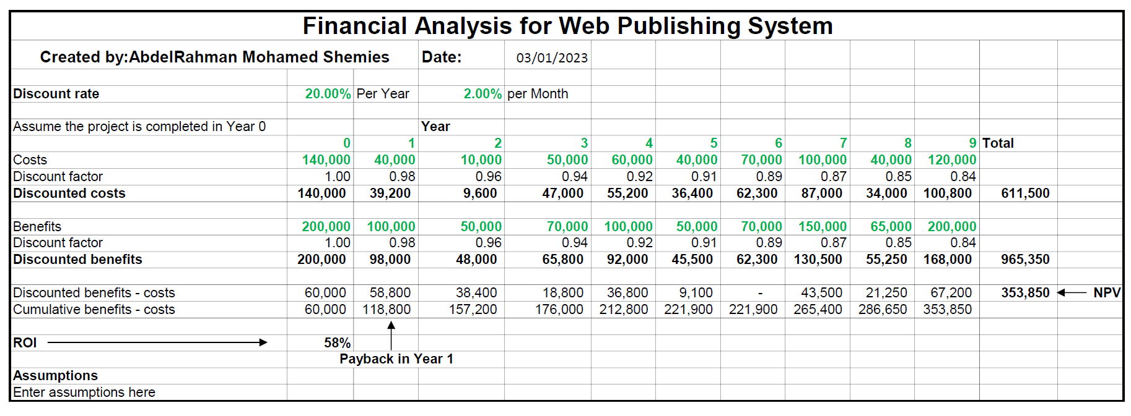

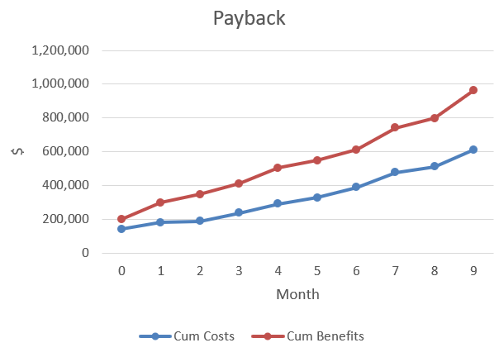

**IV.** Original and revised project plans and schedules (WBS, Gantt charts and network diagrams, cost estimates, communications management plan, etc.)

Work Breakdown Structure Template for

Web Publishing System

**Prepared by:** Abdelrahman Mohamed Shemies **Date: 30/12/2022**

1. Project Initiation
   1. Define project scope and objectives
   2. Identify stakeholders
   3. Develop project charter
2. Planning
   1. Define project deliverables and milestones
   2. Develop project schedule
   3. Determine resources and budget
      1. Obtain project funding and resources
      2. Create project schedule and budget
   4. Create risk management plan
      1. Identify and analyze risks
   5. Identify stakeholders
      1. Define project team roles and responsibilities
      2. Establish communication plan
   6. Create project plan
3. Analysis and Design
   1. Conduct requirements gathering and analysis
   2. Create system and user interface designs
      1. Develop user interface design
      2. Create system architecture and technical design
   3. Develop database schema
   4. Create prototype or mock-up of system
   5. Develop technical documentation
4. Implementation
   1. Develop code for system and database
   2. Integrate system components
   3. Procure hardware and software components
   4. Set up development environment
5. Testing
   1. Develop and execute test plan
   2. Conduct unit, integration, and system testing
   3. Identify and fix defects
   4. Perform performance and load testing
   5. Conduct user acceptance testing
6. Deployment
   1. Install system on servers
      1. Install system in production environment
      2. Configure system and test in production environment
      3. Perform final system acceptance testing
   2. Train users on system usage
7. Maintenance and Support
   1. Monitor system performance and usage
   2. Address user feedback and issues
   3. Implement system updates and upgrades
   4. Enhance system features and functionality
   5. Update system documentation
8. Project Close
   1. Review project performance and outcomes
   2. Document lessons learned
   3. Archive project documents and materials

Gantt Chart

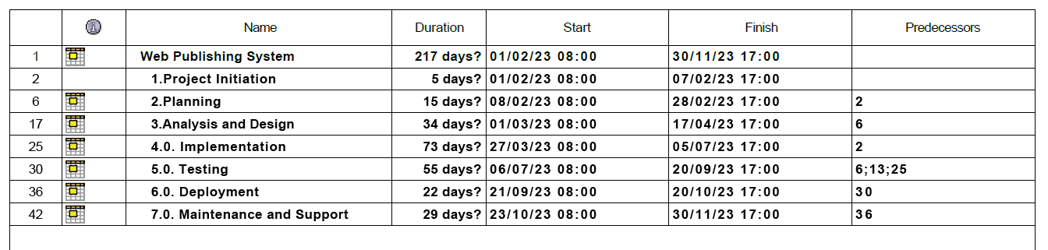 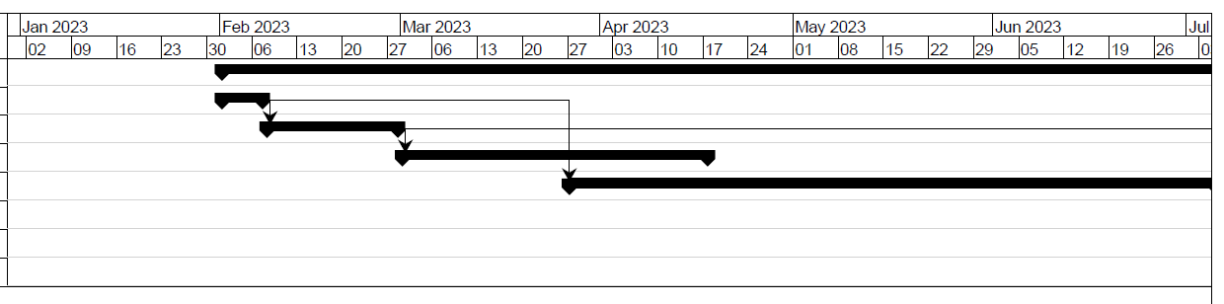 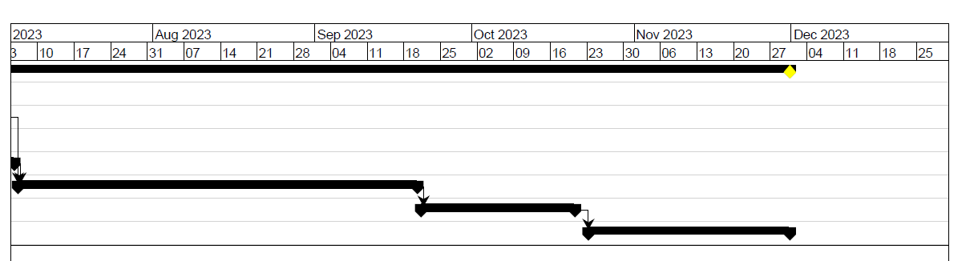

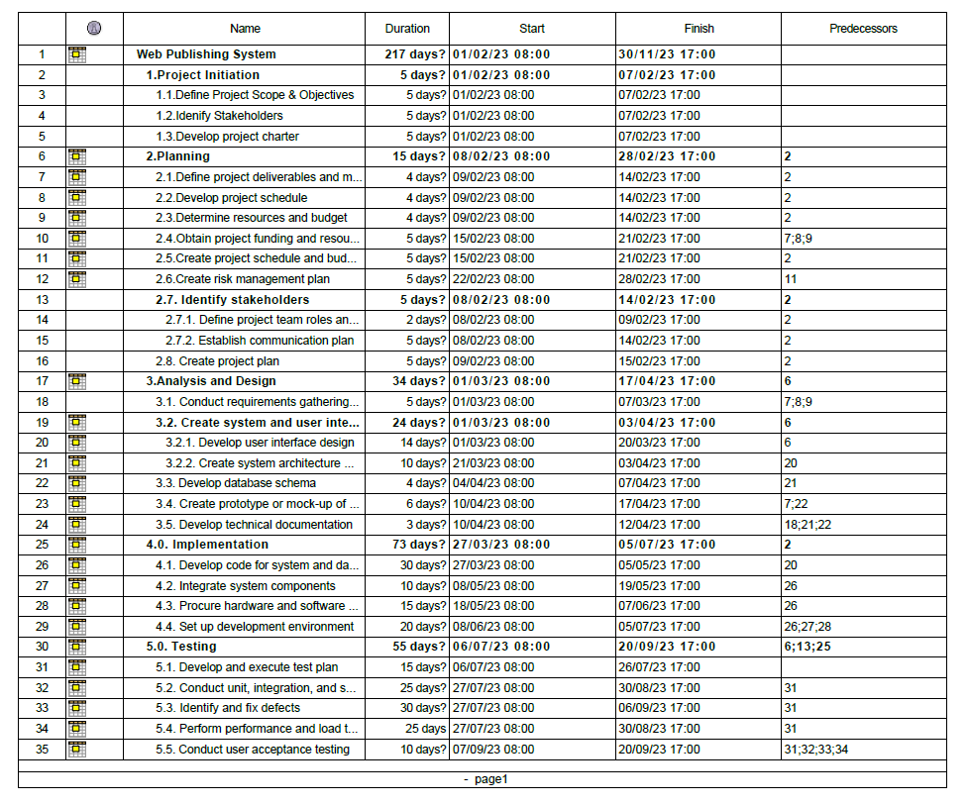

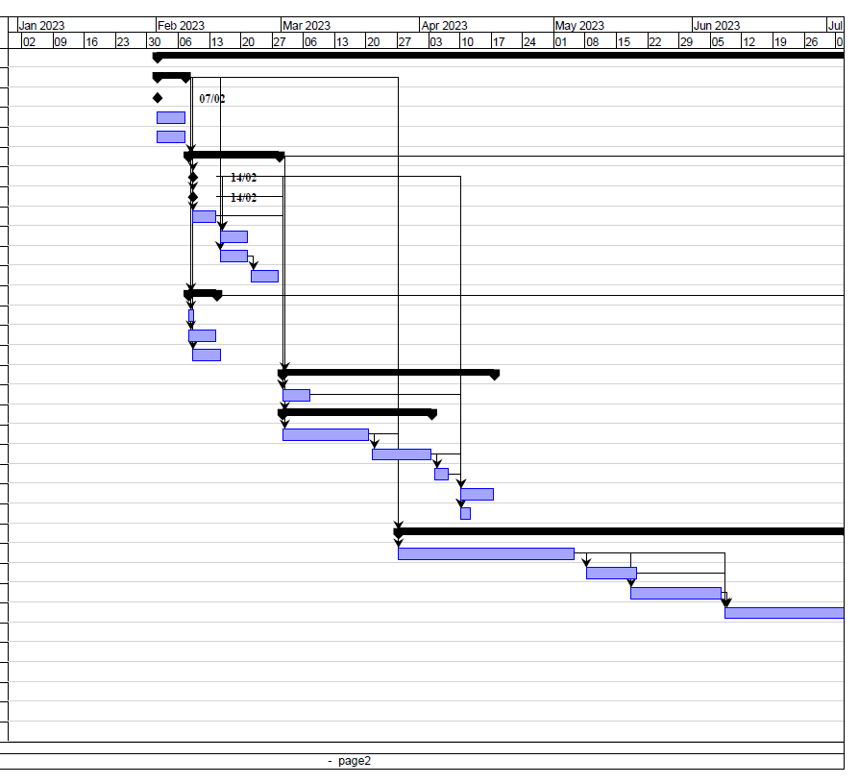 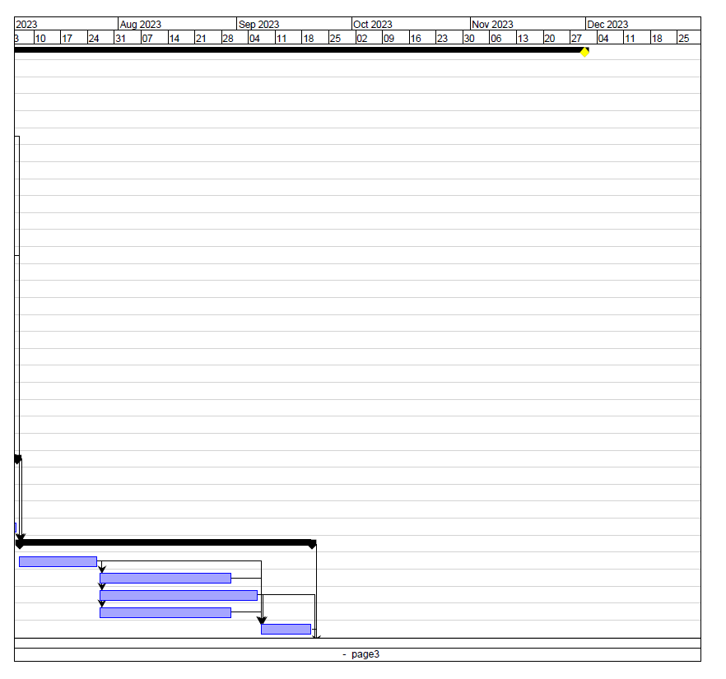 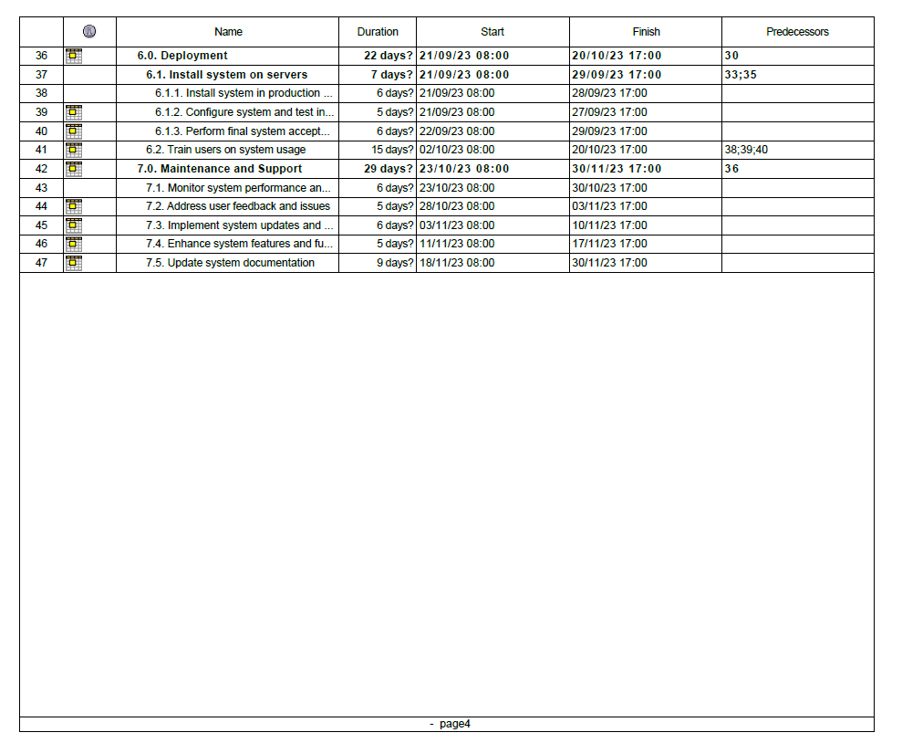 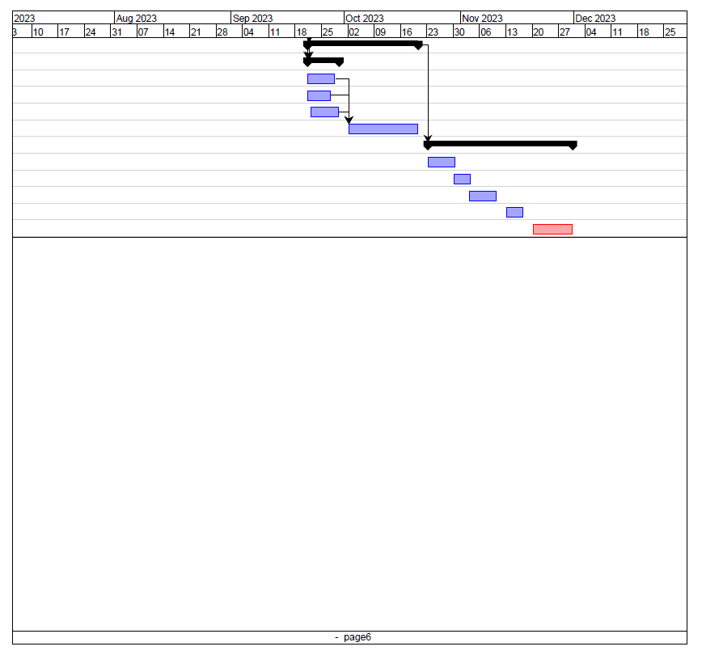

Network Diagram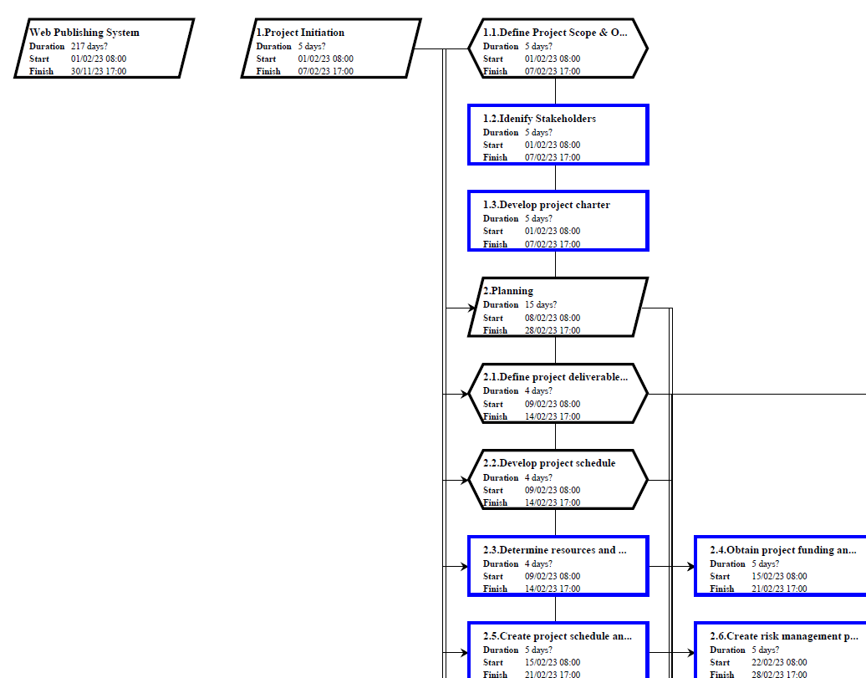 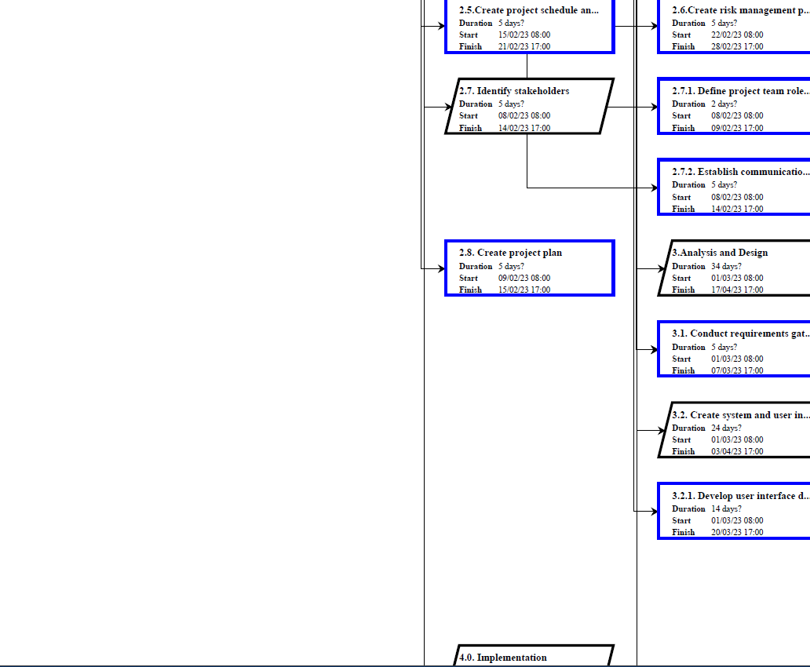 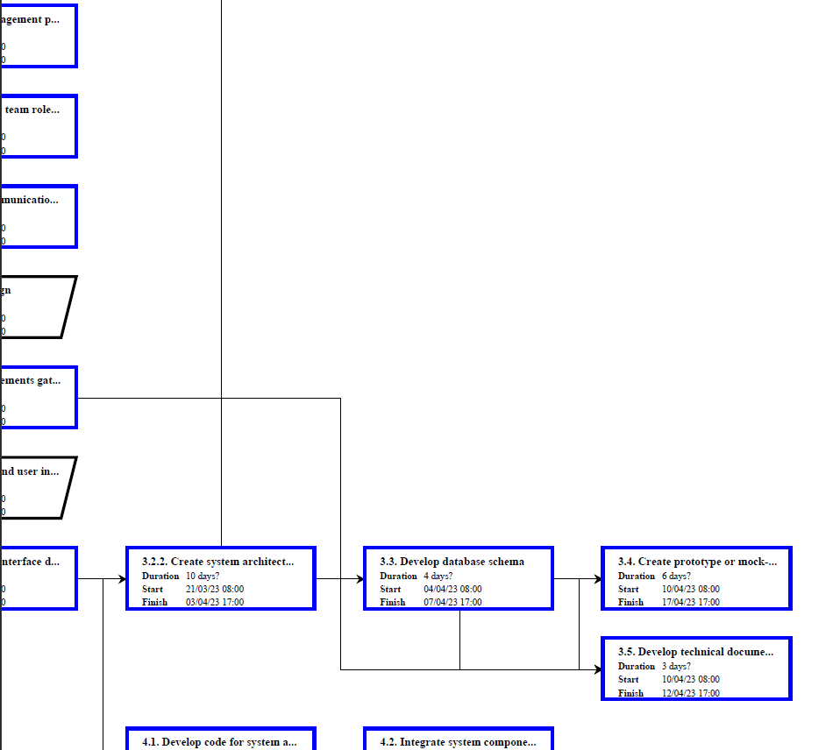 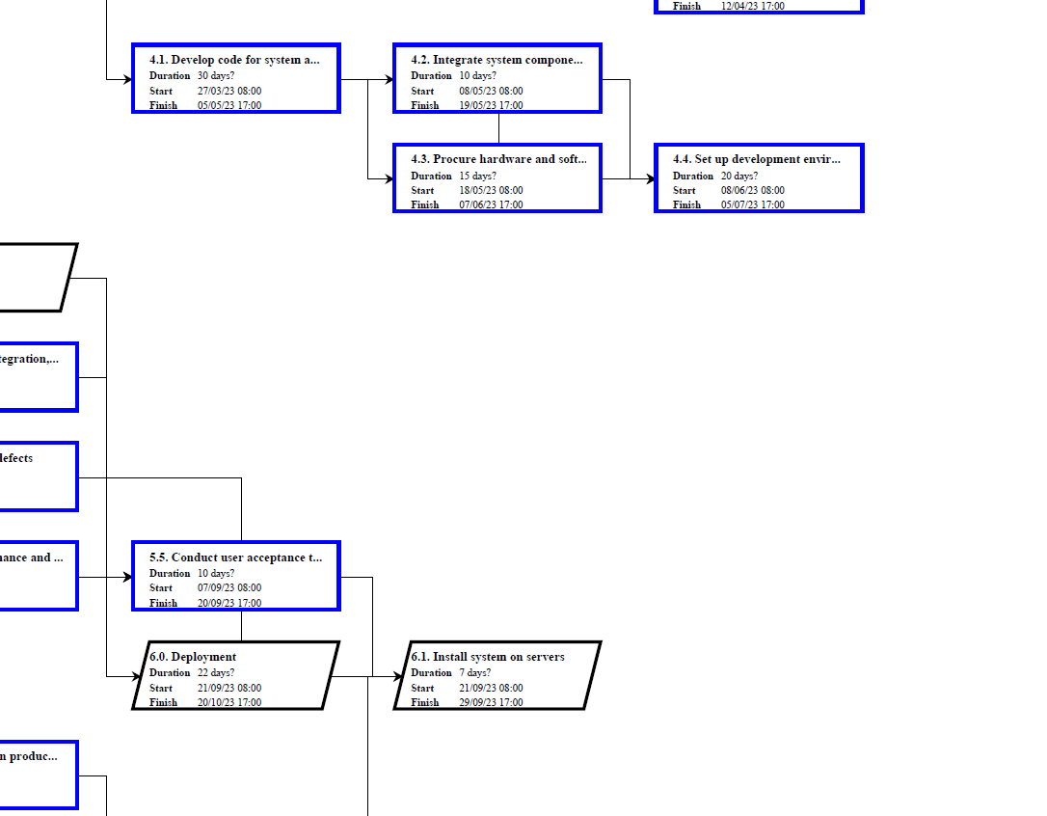 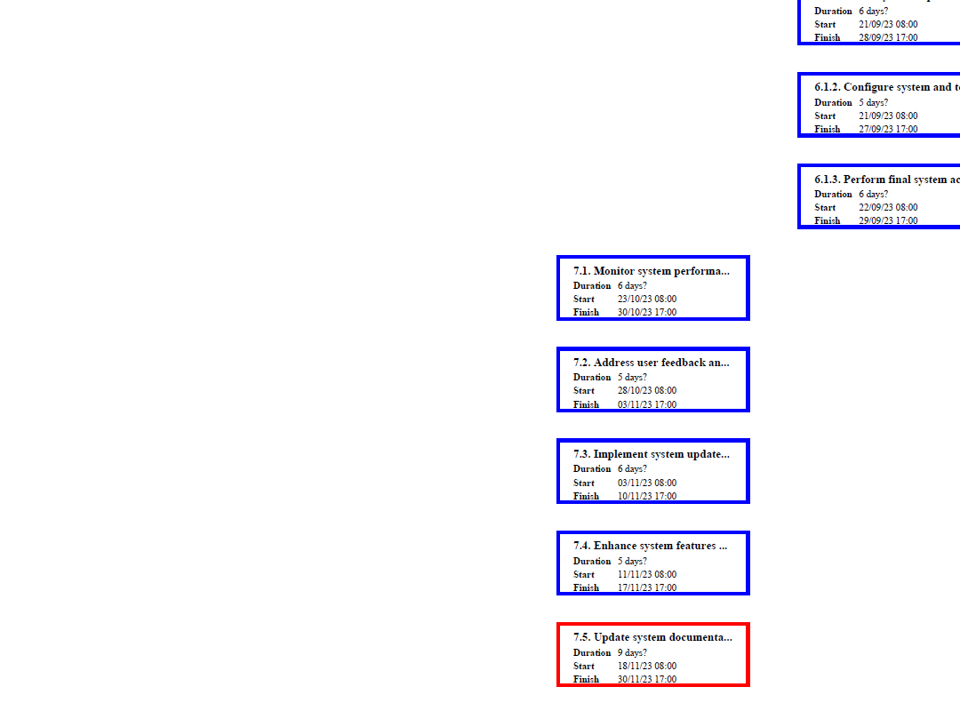 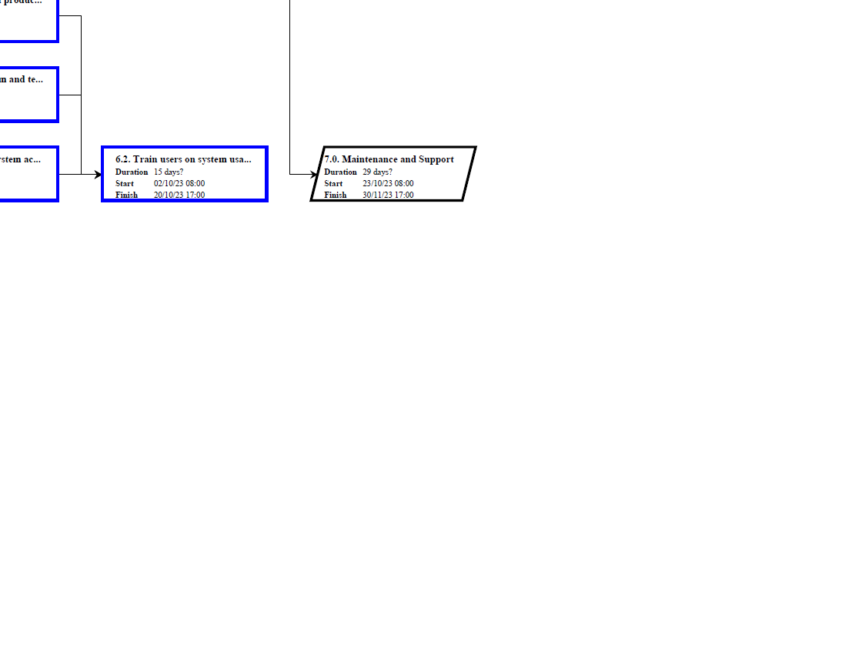

**VII.** Deliverables, as appropriate

|  |  |
| --- | --- |
| Months |  |
| 1: February | * Initial design document * The main user interface (GUI) will be developed and delivered to the client for acceptance * User authentication functionality will be implemented to identify and verify the various actors (e.g. editors, authors, reviewers) in the system. |
| 2: March | * Prototype with basic functionality Months |
| 3-5: April-June | Meeting #1 confirming the Prototype   * The search engine will be fully developed and deployed in the system. * The backend functionality will be implemented, including any necessary data storage and processing. * The main databases for the system will be developed and implemented. * The user interface (GUI) may be modified as needed. * An external historical database will be implemented and integrated into the system. |
| 6-7:  July-August | Meeting #2   * The main and historical databases will be connected and used in the article management system. * Initial use cases for different actors (e.g. editors, authors, reviewers) will be implemented. * The editor, reviewer, and author functionalities will be added to the system. * Various use cases for these functionalities will be implemented. * Unit testing will be conducted to verify the functionality of individual components. * All test cases and scenarios will be completed. |
| 8-9: September- October | Meeting #3   * Internal and external testing will be carried out to ensure the system is reliable and performs as expected. * Testing scenarios and documentation will be provided, including any bugs discovered and how they were addressed. |
| 10: November | Meeting #4   * Integration testing will be completed to ensure all components of the system are working together as intended. * A comprehensive report will be compiled, including all testing scenarios and any bugs that were discovered and resolved. * User manual * Training materials * Project updates and progress reports * Maintenance and support plan * Security and data protection measures |

**VIII.** Audit reports

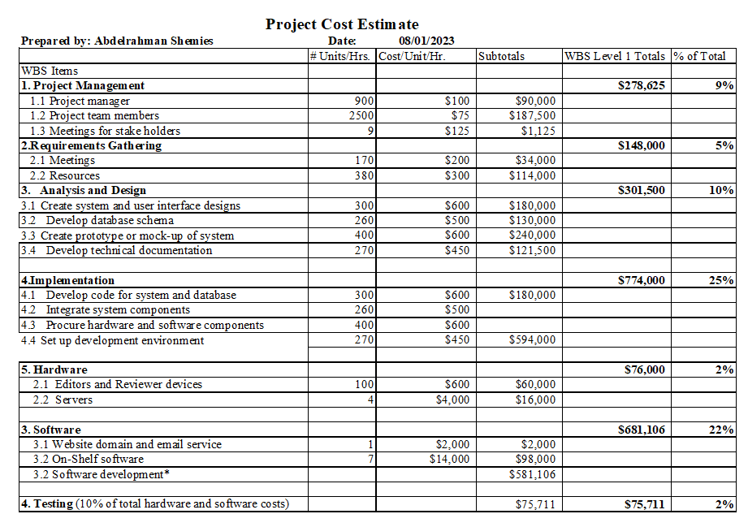

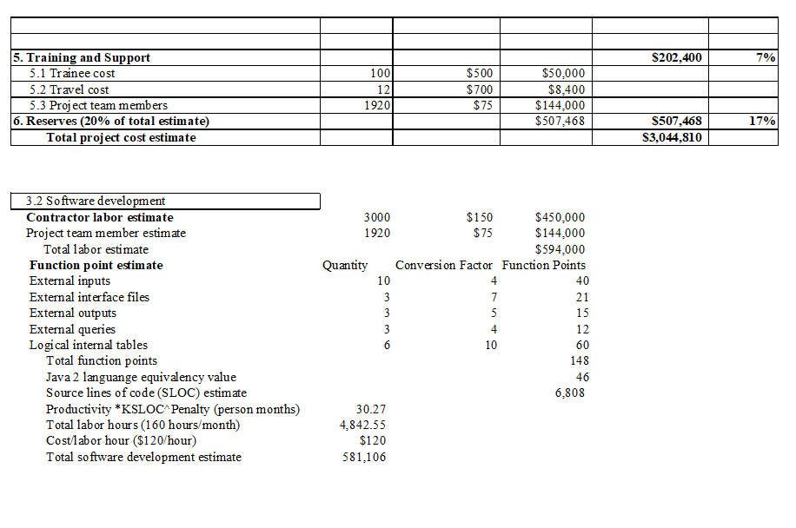

**IX.** Lessons learned reports

|  |
| --- |
| **Prepared by: Abdelrahman Mohamed Shemies** **Date:8/1/2023**  **Project Name: Web Publishing System**  **Project Sponsor:**  **Project Manager: Abdelrahman Mohamed Shemies**  **Project Dates:1/2/2023-30/11/2023**  **Final Budget: $3,044,810** |
| 1. Did the project meet scope, time, and cost goals?   Despite facing several challenges during the project, including team members falling ill and issues with UI/UX contractors, we were able to successfully deliver the project within the specified timeframe. However, we should have been more mindful of potential delays caused by unforeseen circumstances, such as health risks, and factored them into our project schedule. Additionally, the COVID-19 pandemic had an impact on the project, causing delays and additional costs as we had to rehire UI/UX designers due to issues with the original contractors. Despite these challenges, the project was completed to a high standard thanks to the expertise of the team members.   1. What was the success criteria listed in the project scope statement?   The scope of work for this project includes the development and implementation of an online journal website and related systems for managing and publishing articles. This will involve the creation of user interfaces for authors, reviewers, and editors, as well as the development of a database to store articles, authors, reviewers, and other relevant information. The hardware components of the project will include servers for hosting the website and database, and possibly client machines for the editors. The software components will include the web server software, database management software, and any custom software developed specifically for this project. The exact nature of the work will involve designing and implementing the user interfaces, setting up and configuring the hardware and software components, and testing and debugging the system.  The Web Publishing System will have the following features: An interface for the editor to create and manage a list of authors and reviewers, including the ability to add, edit, and delete entries.An interface for authors to submit articles for review, including the ability to attach files and enter metadata such as the article title and abstract.An interface for reviewers to view and review articles, including the ability to leave comments and feedback for the authors.An interface for the editor to view and manage the review process, including the ability to assign articles to reviewers, view comments and feedback, and make decisions on whether to accept or reject articles.An email system to facilitate communication between the editor, authors, and reviewers, including the ability to send and receive preformatted reply forms.A relational database to store information about authors, reviewers, and articles, including metadata such as the article title and abstract, and the status of the review process. Main Actors   * Editor * Author * Reader * Reviewers  1. Reflect on whether or not you met the project success criteria.   The majority of the project's success criteria were accomplished, particularly in terms of surpassing the competition and implementing an advanced filtering system. However, the website's loading time and functionality were not fully met as per the set goals.   1. In terms of managing the project, what were the main lessons your team learned?   One of the key takeaways from managing this project was the importance of clear communication and a cohesive team dynamic in achieving project success. Additionally, ensuring a healthy work environment was also deemed crucial.   1. Describe one example of what went right on this project.   One positive aspect of the project was the hiring of an experienced development team who had previously worked on large and reputable projects. Their expertise allowed the team to successfully navigate through challenges and complete the project within the specified timeframe.   1. Describe one example of what went wrong on this project.   One example of a challenge encountered during the project was difficulties with the UI/UX contractors, particularly in regards to their differing approaches and issues with their payment.   1. What will you do differently on the next project based on your experience working on this project?   Based on our experience on this project, we will make sure to more carefully estimate the time needed for the project and consider potential health risks for team members. In addition, we will avoid using contractors or freelancers for UI/UX design and instead hire full-time employees to prevent issues with payroll and communication. We will also prioritize monitoring the health and well-being of our team members to ensure a healthy and productive work environment. Additionally, we will take into account the impact of the coronavirus pandemic and plan for potential delays or disruptions in the project schedule. |